BCIT, Comp 4952 Technical Programming 2
Technical Programming Option

Option Head Mirela Gutica
Fall 2015

Mark: ________/100 Name: Jens Christiansen

Lab 4

This is an independent project. The assignment should be handed-in no later than Sunday November 8 2015, 11:30pm. No late assignments will be accepted.

Part 1:
- Implement an ASP.NET MVC application with the following requirements:

- Create a DB according to the following schema:
- 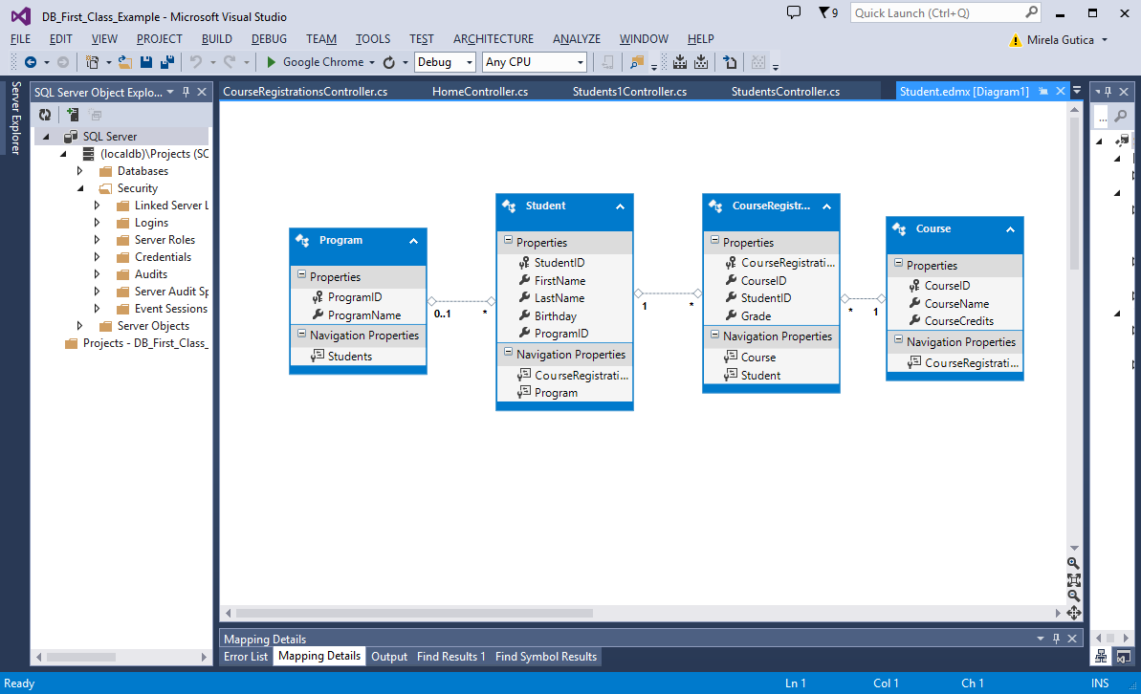
- Start with an MVC project.
- Follow the steps in Module 3 ASP.NET MVC.
- Use the database-first approach to create the models.
- Add controllers and modify the views.
- Follow the lecture notes and observe several aspects of the project.
- Upload the application on Azure and D2L.
- Indicate the URL in your D2L submission.

Part 2:
- Follow the exercises in the lecture notes Module 3 ASP.NET State Management.

